**AI Agents Comprehensive Report**

**AGENT-1**

**Agent Name:** Chat with Any YouTube Video Agent

**Description:**

This AI agent allows users to interact with the content of any YouTube video through a conversational interface. By leveraging transcription, embedding generation, and retrieval-augmented generation (RAG), the agent provides insightful, context-aware answers based on video content.

**Working**

The agent performs the following steps in sequence:

1. **YouTube URL Input**: The user provides a YouTube video URL.
2. **Audio Extraction**: The video’s audio is extracted using a YouTube data processing utility.
3. **Transcription**: The extracted audio is transcribed into text.
4. **Embedding Generation**: The transcript is converted into vector embeddings using OpenAI text embedding model
5. **Vector Indexing**: Embeddings are stored in a Chroma vector database for fast retrieval.
6. **User Chat Interface**: The user can ask questions about the video.
7. **RAG Mechanism**: Relevant transcript segments are retrieved based on the user’s query and passed to an LLM (e.g., gpt-4o-mini) to generate a coherent response.

**Input**

* A valid YouTube video URL
* User’s natural language queries related to the video content

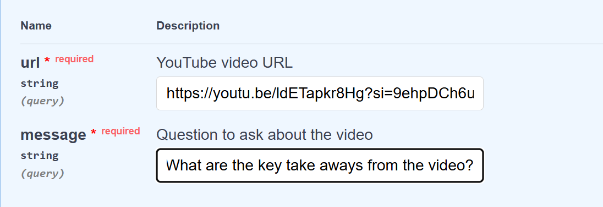

**Output**

* Human-like, contextually relevant responses based on the content of the video
* Ability to explore specific topics, key moments, or summarization from the video via chat

"response": "*The key takeaways from the video are the process of creating four images and four five-second-long videos from a video topic about a beaver building a house, using various AI agents to generate content, analyze text, and create visuals that align with the content. The video also explains the workflow of feeding information to different agents and rendering the final output for use in Create-a-Mate template. If you want more detailed information, you can check out the full breakdown video linked earlier.*"

**Workflow Diagram:**

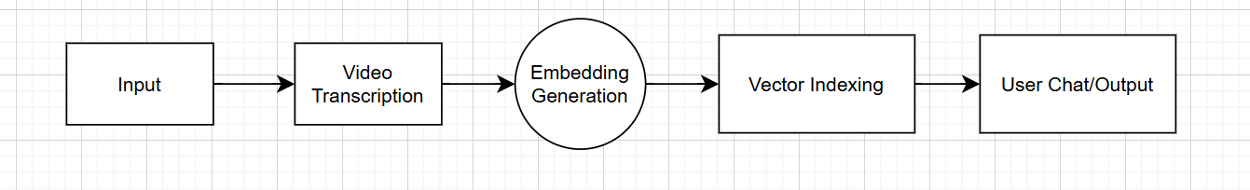

**AGENT-2**

**Agent Name:** Market Analysis agent

**Description**

The Market Analysis Agent is a specialized AI-powered research assistant designed to perform rapid and comprehensive assessments of market landscapes. It leverages real-time data, intelligent summarization, and web-sourced analytics to deliver actionable insights regarding industry trends, competitor activity, consumer behavior, and market opportunities.

**Working**

1. **Receive Market Query**  
   The agent accepts a company with domain as an input from the user.
2. **Initiate Real-Time Research**  
   Executes live web and API-based searches to collect the latest market data.
3. **Extract Key Insights**  
   Filters and retrieves relevant statistics, trends, and competitor signals.
4. **Synthesize Findings**  
   Uses an LLM to summarize insights into actionable business intelligence.
5. **Deliver Structured Report**  
   Outputs a clear, formatted analysis tailored for strategic decision-making.

**Input**

* Company name with their domain (e.g., “openai.com”)

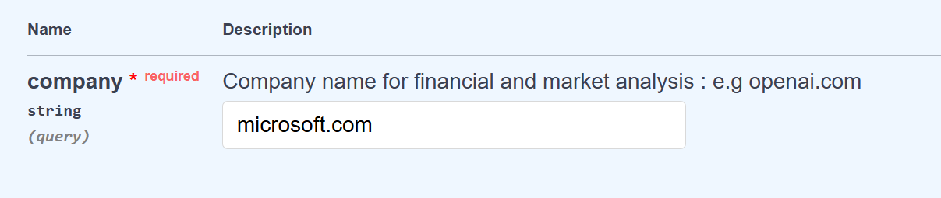

**Output**

* A comprehensive market analysis report, including:
  + Executive Summary
  + Key findings
  + Revenue
  + Market Overview and Trends
  + Competitive insights
  + Risk Assessment
  + Recommendations
* (A downloaded sample doc is being attached to this document eg: analysis report.docx)

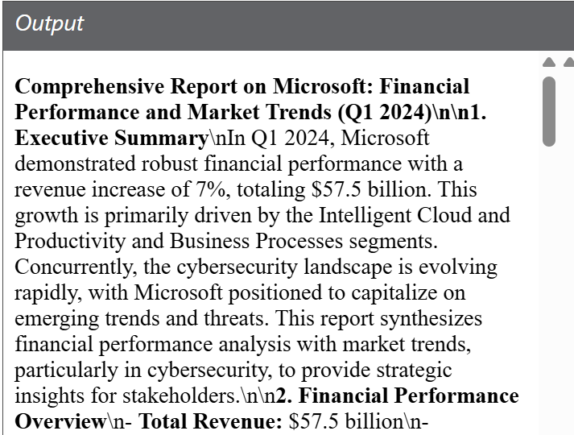

**Workflow Diagram:**

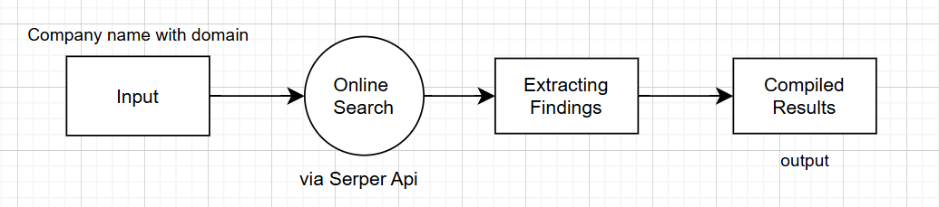

**AGENT-3**

**Agent Name:** AI Research & Writing Agent

**Description**

This agent functions as an intelligent research assistant and content creator, designed to generate high-quality reports or blogs on any given topic. It automates the entire content development workflow—from topic exploration and fact-finding to well-structured article drafting—making it an ideal companion for marketing, editorial, and research teams.

**Working**

1. **Receive Topic Input**  
   The user provides a topic or headline for the content to be created.
2. **Perform Online Research**  
   The agent uses the Serper.dev API to search the internet for up-to-date, relevant information.
3. **Extract and Curate Content**  
   Gathers credible facts, statistics, and supporting context from search results.
4. **Draft Structured Content**  
   Uses an LLM(gpt-4o) to synthesize research into a structured blog post or report.
5. **Output Final Document**  
   Delivers the draft in user-ready pdf format.

**Input**

* A topic or prompt (e.g., “Impact of AI on Healthcare”)

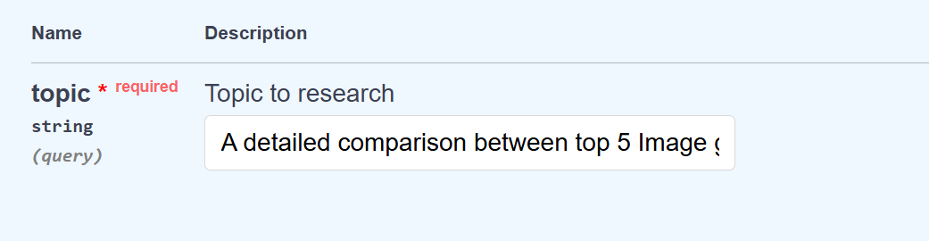

**Output**

* A well-researched and coherent blog or report in pdf.
* Optionally segmented with headings, bullet points, and citations.
* (A downloaded sample generated pdf is being attached to this document eg: report.pdf)

**Workflow Diagram:**

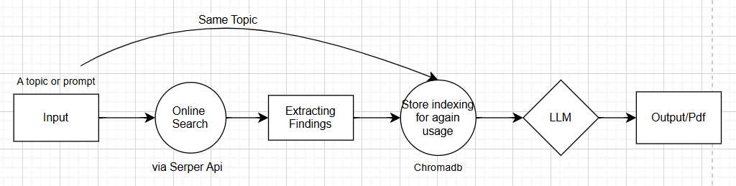

**AGENT-4**

**Agent Name:** Social Media Content and Image Creator

**Description**

This AI agent is designed to assist marketing and content teams by generating tailored social media posts along with matching visuals. It takes a content brief and platform target, then produces optimized text and an AI-generated image using DALL·E 3—ensuring fast, cohesive, and engaging social media assets ready for deployment.

**Working**

1. **Accept Content Brief**  
   Receives inputs including the target platform, content brief, creativity level, and image aspect ratio.
2. **Generate Post Text**  
   Uses an LLM to craft concise, compelling social media copy tailored to the selected platform and brief.
3. **Create Visual Asset**  
   Generates an AI image using DALL·E 3 based on the content theme and specified aspect ratio.
4. **Package Final Output**  
   Returns a ready-to-use post with paired text and imagery, optimized for social media publishing.

**Input**

* platform: Target platform (e.g., Instagram, LinkedIn, X)
* content-brief: Short creative brief or topic
* creativity: Float value (0.0 to 1.0) controlling text creativity
* image_aspect_ratio: Desired image aspect ratio (e.g., "1:1", "16:9")

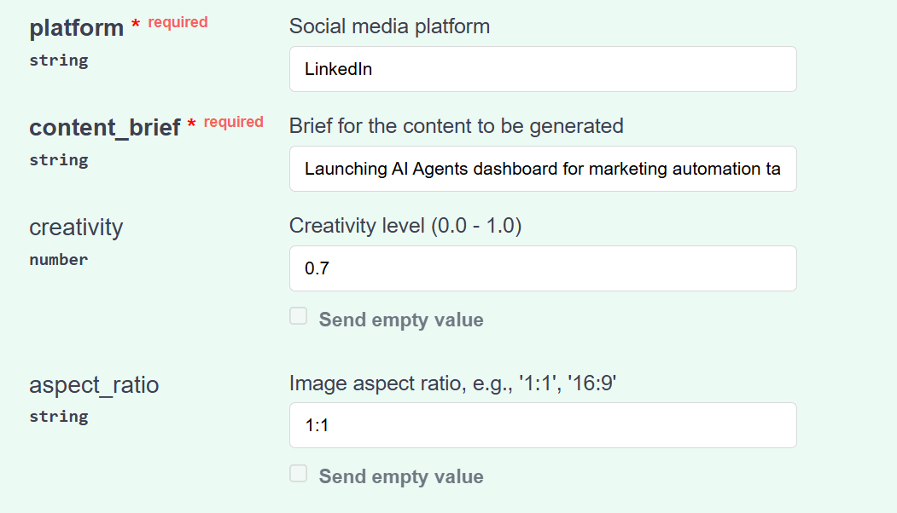

**Output**

* A well-written, platform-tailored social media post including emojis, hashtags, CTA
* A visually relevant AI-generated image

**Post-generated : “**

🚀 Exciting News in Marketing Automation! 🚀

We are thrilled to announce the launch of our AI Agents Dashboard, designed to revolutionize the way you manage your marketing tasks! 🎉✨

Say goodbye to tedious manual processes and hello to seamless automation! Our innovative dashboard allows you to:

- 🤖 Automate repetitive marketing tasks with ease

- 📊 Gain real-time insights and analytics to make data-driven decisions

- 🔗 Integrate with your favorite marketing tools for a streamlined workflow

- 💡 Personalize customer interactions at scale

With the power of AI at your fingertips, you can focus on what truly matters: crafting engaging strategies and building meaningful connections with your audience. 🌟

Join the future of marketing automation with us! Ready to transform your marketing efforts? Click the link below to explore the new AI Agents Dashboard and see it in action! 🔗👇

#MarketingAutomation #AIAgents #Innovation #DigitalMarketing #BusinessGrowth #AutomationTools #TechForGood #LeadGeneration #CustomerEngagement

**”**

**Image-generated :**



**Workflow Diagram:**

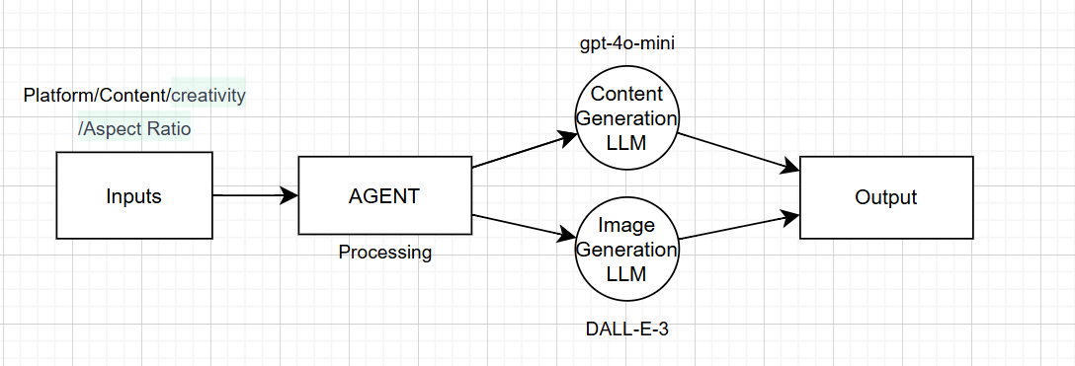

**AGENT-5**

**Agent Name:** Chat with Any Website

**Description**

This agent allows users to interact with the content of any website through a conversational interface. By intelligently scraping, embedding, and caching the site’s content, the agent ensures real-time query responses while minimizing redundant processing. It’s ideal for research, competitor analysis, or customer support scenarios.

**Working**

1. **Receive Website URL**  
   The user provides a valid website link to initiate interaction.
2. **Scrape Website Content**  
   Uses a Selenium-based scraper to extract all readable content from the website.
3. **Generate Embeddings**  
   Converts the extracted content into vector embeddings for semantic understanding.
4. **Store or Reuse Embeddings**  
   Saves the embeddings in a Chroma DB; if the same URL is used again, the agent skips scraping and reuses existing data.
5. **Chat with User**  
   Uses a retrieval-augmented LLM to answer user questions based on the website’s content.

**Input**

* A valid website URL
* Natural language queries from the user

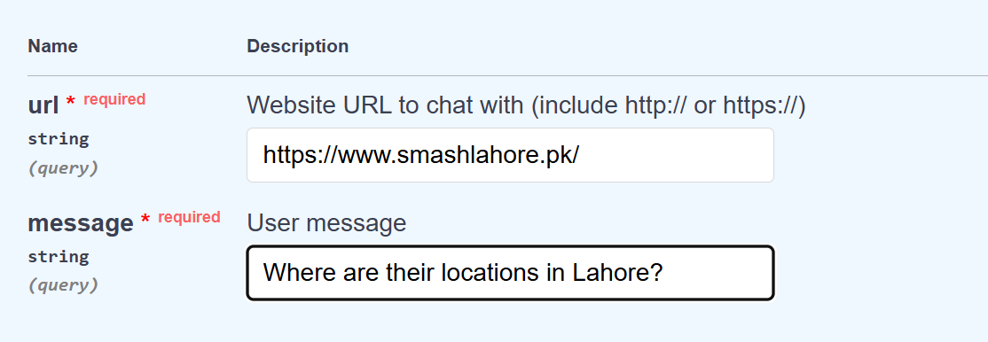

**Output**

* Intelligent responses grounded in the website’s content
* Optionally cached site data for improved response time on repeated queries

"bot_response": "*Smash Lahore has several locations in the city, specifically in the following areas:*

*- SMASH JOHAR TOWN - 366, Block N, Phase 2 Johar Town, Lahore*

*- SMASH CANTT - 11, Bagh Ali Road, Falcon Complex, Lahore Cantt\n3.*

*- SMASH DHA PHASE 2 - 74 T Block Commercial Market, DHA Phase 2, Lahore*

*All locations operate from 12:00 PM to 04:00 AM.*"

**Workflow Diagram:**

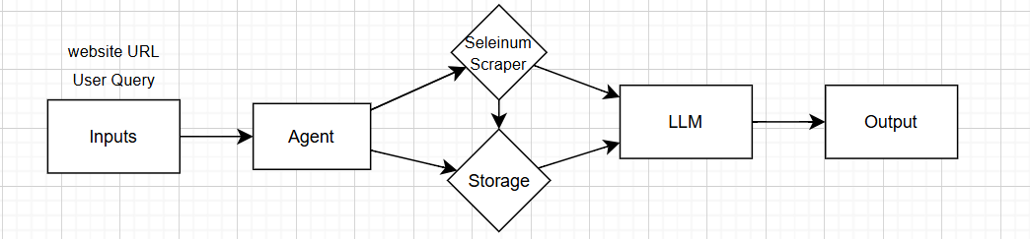

**AGENT-6**

**Agent Name:** Post Ideas Generation Agent

**Description**

This agent streamlines the creative process by transforming structured inputs into fully developed content assets. By conducting topical research and understanding the platform, tone, audience, and keywords, it generates fresh content ideas and delivers ready-to-use posts that align with brand and audience expectations.

**Working**

1. **Receive Creative Brief**  
   Accepts topic, platform, tone, audience, and keywords as input.
2. **Conduct Contextual Research**  
   Gathers relevant insights to inform post direction and voice.
3. **Generate Post Ideas**  
   Suggests multiple creative directions tailored to the platform and audience.
4. **Write Ready-to-Use Content**  
   Produces finalized versions of selected ideas, formatted for posting.

**Input Parameters**

**Topic/Theme:** AI agents for marketing automation  
**Platform:** LinkedIn  
**Tone:** professional  
**Target Audience:** tech professionals  
**Keywords:** productivity, AI tools, workflow automation, efficiency

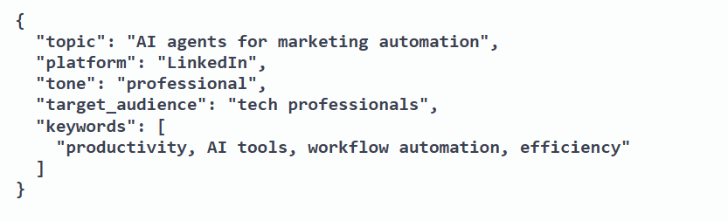

**Output**

* Brief **Research Findings** based on topic and keywords
* A set of **Post Ideas** suited to platform, tone, and audience
* **Ready-to-Use Content** for immediate posting

**Note : (**A doc file will also be attached**)**

**AGENT-7**

**Agent Name:** Deep Research Agent

**Description**

The Deep Research Agent is built on top of the open-source [gpt-researcher](https://github.com/assafelovic/gpt-researcher) framework. It autonomously performs in-depth research on any given topic by breaking down the query into sub-questions, performing online searches, retrieving credible sources, and synthesizing findings into a well-structured, reference-backed research report.

**Working**

1. **Accept Research Topic**  
   Takes a user-defined topic or research question as input.
2. **Decompose Into Sub-Questions**  
   Breaks the topic into granular, focused questions to guide research.
3. **Search the Web**  
   Performs automated online searches to gather relevant information.
4. **Evaluate and Select Sources**  
   Filters out low-quality links and selects the most trustworthy sources.

**Input**

* A research question or topic

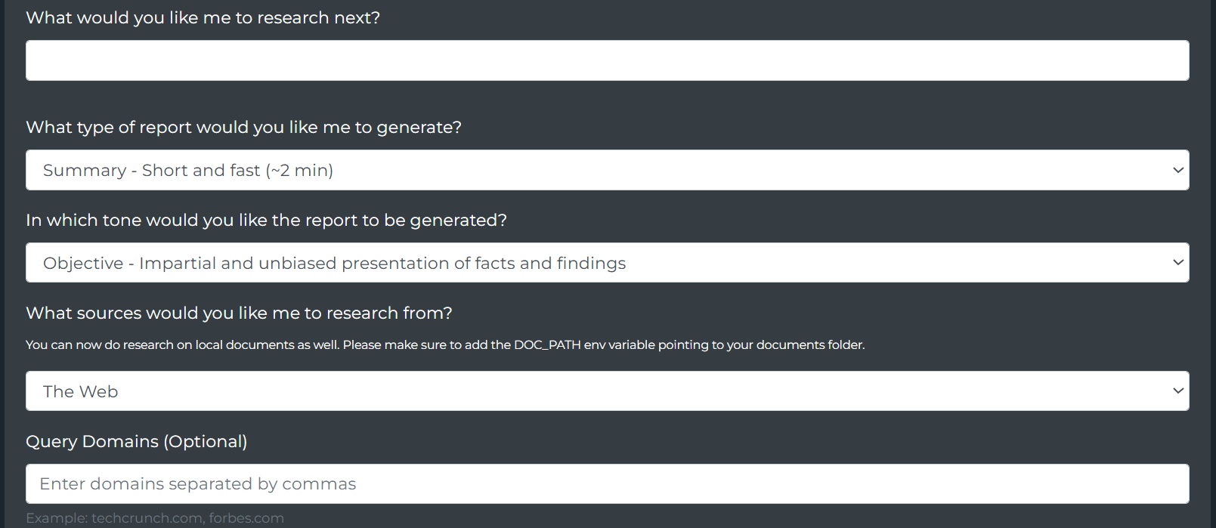

**Output**

* A detailed multi-section research report
* Referenced sources with summaries
* Structured format ready for presentation or further editing
* **Note : (**A research pdf file will also be attached**)**

**Workflow Diagram:**

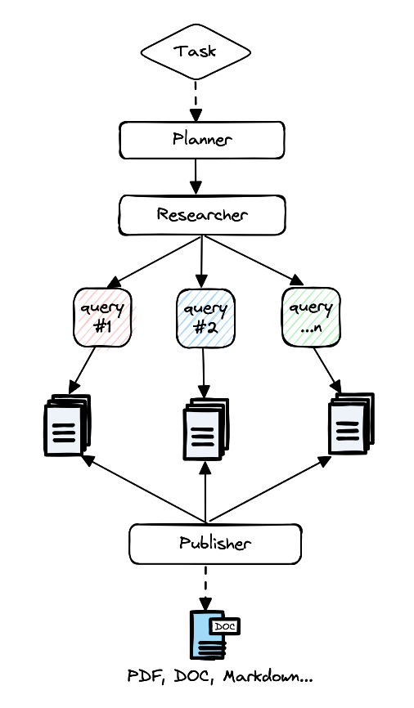

**AGENT-8**

**Agent Name:** Marketing Strategist Agent

**Description**

The Marketing Strategy Agent empowers users to generate a comprehensive, startup-ready go-to-market plan. By leveraging domain-specific analysis and goal-oriented input, it crafts a detailed strategic document—including tactics, channels, KPIs, campaign ideas, and marketing copy—to support targeted growth and engagement across relevant platforms.

**Working**

1. **Accept Business Input**  
   Takes the company domain and a brief description of the marketing objective.
2. **Contextual Research**  
   Understands the company's space, product, and target market.
3. **Strategy Generation**  
   Develops a structured marketing strategy tailored to the business goal.
4. **Campaign Ideation**  
   Proposes original, relevant marketing campaign ideas and execution plans.
5. **Generate Copy**  
   Provides compelling, platform-specific marketing copy for campaigns.

**Inputs**

customer_domain : Enter the company domain (e.g., example.com):

project**_**description **:** Enter the project description including context, goal, or objective for marketing strategy

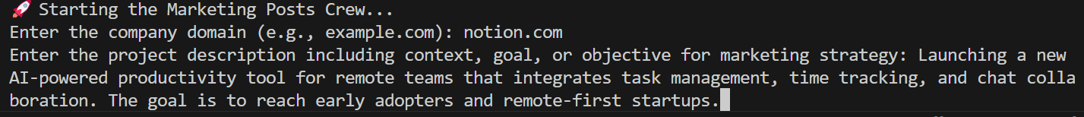

**Output**

A detailed, markdown-formatted strategy report that includes:

* ✅ **Marketing Strategy**
  + Tactics
  + Channels
  + KPIs
* ✅ **Campaign Ideas**
  + Description, audience, and channels for each idea
* ✅ **Marketing Copy**
  + Polished promotional content for campaigns

**Workflow Diagram:**

